Ain Shams University Faculty of Engineering Structural Department

Fourth Year Civil

FIELD SPLICE CONNECTION

(Design Procedure + Solved Example)

Ain Shams University Faculty of Engineering Structural Department

Fourth Year Civil

Design Procedure

### GIVEN SECTION DIMENSIONS For Flange bf & tf & For Web hw & tw

1. **GET SPLICE PLATES DIMENSIONS**

|  |  |
| --- | --- |
| **For Plate (1) (**b1 & t1 ) |  |
|  |
| **where b1 = bf & t1 = 0.5 tf** |
| **For Plate (2) (**b2 & t2 ) |
|  |
|  |
| **& get t2** |
| **For Plate (3) (**b3 & t3 ) |
|  |
|  |
| **& get t3** |

1. **GET REQUIRED NO. OF BOLTS A. SPLICE OF FLANGE PLATE**

* **Max Capacity C =T = Area of flange x 0.8 Fy**

# Resistance of bolt

#### -----------[1]

**NOTE -** It is recommended to assume Edge distance= 2d **K1 = 2.5 & =0.67**

**FROM [1] & [2] Get RLeast**

#### ------------[2]

## CHECK NET SCTION FRACTURE (Tension flange):-

### ( )

Ain Shams University Faculty of Engineering Structural Department

Fourth Year Civil

# B. SPLICE OF WEB PLATE

**Resistance of bolt**

## -----------[1]

**NOTE -** It is recommended to assume Edge distance= 2d **K1 = 2.5 &=0.67**

## ------------[2]

**FROM [1] & [2] Get RLeast**

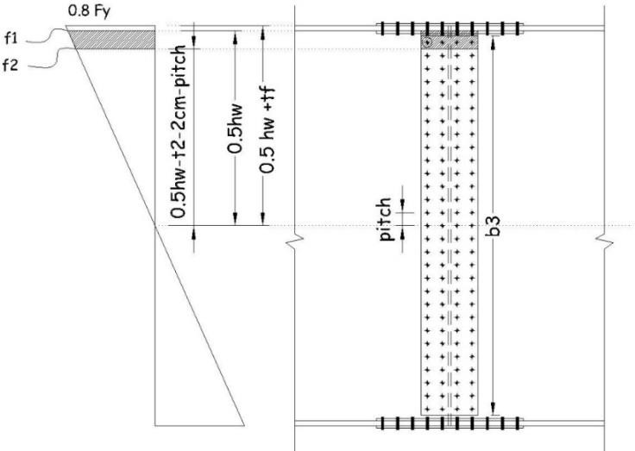

### —

(

### 

)

( )

CHECK ON CRITICAL BOLT (assuming 2 rows)

### [ (

### )

### ]

√

Ain Shams University Faculty of Engineering Structural Department

Fourth Year Civil

## Design a bolted field splice for the main girder section at 2.40m from its midspan. Consider that the shear force at this location is 110 t.

**Use bolts M27 grade (10.9) Category C.**

**Where Main Girder dimensions ST(52) (**hw = 400 cm& tw=1.8 cm) , **(**bf = 80 cm& tf=4.0 cm) SOLUTION

# GET SPLICE PLATES DIMENSIONS

|  |  |
| --- | --- |
| **For Plate (1) (**b1 & t1 )    **where b1 = 80 cm & t1 = 0.5 tf =0.5(4)=2.0 cm** |  |
| **For Plate (2) (**b2 & t2 )        **& get t2 = 2.2 cm** |
| **For Plate (3) (**b3 & t3 )      **& get t3=1 cm** |

1. **GET REQUIRED NO. OF BOLTS**

## FOR FLANGE

* **Max Capacity C =T = Area of flange x 0.8 Fy = 80*4.0*0.8*3.6 =921.6 t**

## Resistance of bolt

#### = 0.4x10x0.25x3.14x2.72=22.9 t [1]

**= 1.34x5.2x2.7x4.0=75.25 t [2]**

**Get RLeast = 22.9 t**

* **CHECK NET SECTION FRACTURE (Tension flange):-**

(

)

)  (

Ain Shams University Faculty of Engineering Structural Department

Fourth Year Civil

## FOR WEB

## Resistance of bolt

#### = 0.4x10x0.25x3.14x2.72=22.9 t [1]

**= 1.34x5.2x2.7x1.8=33.86 t [2]**

**Get RLeast = 22.90 t**

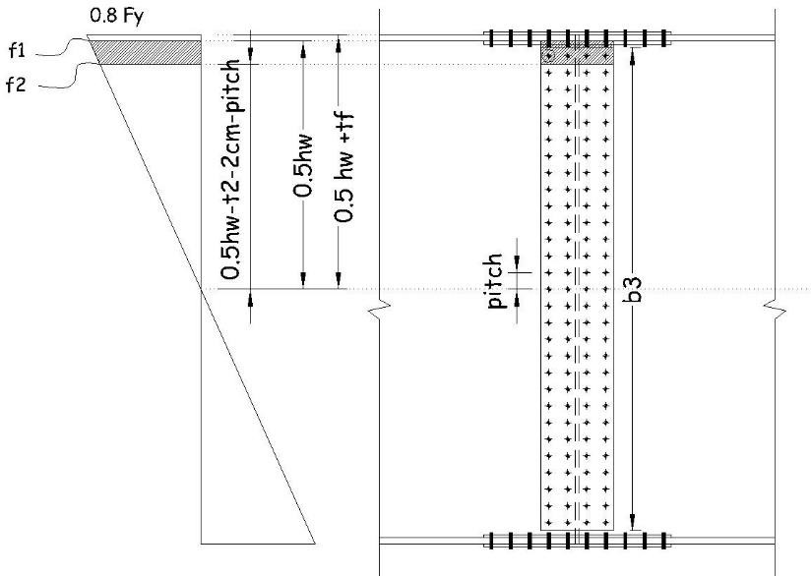

CHECK ON CRITICAL BOLT (assuming 2 rows x 38 bolt)

[ (

) ]

√

#### INCREASE ANOTHER 2 ROW (4rowsx38 bolt)